**2019 ST. MARGARET OF SCOTLAND PARISH ATHLETIC ASSOCIATION**

**GOLF TOURNAMENT**

**SPONSORSHIP OPPORTUNITIES**

**October 11, 2019 - Forest Park Golf Course**

**Please select your sponsorship level(s) and complete this form.**

**BRONZE HOLE SPONSORSHIP $100** - QUANTITY _____________

Your logo & website & contact information will be featured on a sign at a hole.

**GOLD LEVEL SPONSORSHIP $600** - QUANTITY ____________

Your hole sponsorship will include a larger more prominent sign and a foursome in the tournament.

**PLATINUM LEVEL SPONSORSHIP $1200** - QUANTITY ___________

Your 2-hole sponsorship will include the largest and most prominent sign at each hole and TWO foursomes in the tournament.

**LUNCH/DINNER SPONSOR $500** - QUANTITY ____________

Your logo & website will appear on a 2.5’ x 4’ banner which will be displayed in the lunch / dinner area. The same information & imagery will also be featured on a sign placed at one of the holes. You are also

invited to hand out company/product information at your sponsored hole.

**PRIZE DONATIONS**

We are assembling door prizes to award following the tournament. If you would like to donate gift certificates, products

or other items, please fill out the information below

Product Description _______________________________________ Quantity_______ Value_____________

Other prize donation information?________________________________________

Name______________________________ Company________________________________

Address____________________________ City________________________ State_______

Zip_________ Phone________________ Email___________________________________

**PAYMENT**

Enclosed is my check of $___________ made payable to “**SMOS AA”**

**Or**

Please charge my credit card - Card Number_______________________ Exp______ Security Code ______ Zip________

Signature_________________________________ PRINT Name_________________________________________

Card Type: VISA / MC

Please mail checks to Chris Heisig at 5936 Marwinette Ave, St. Louis, MO 63116 Questions? Call Chris at 314-495-1447

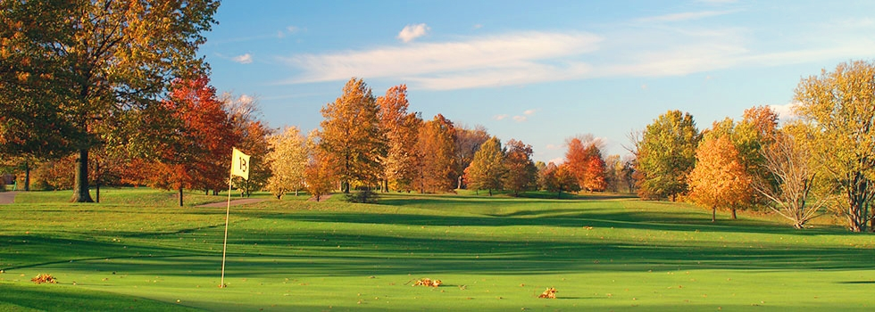

**St. Margaret of Scotland Parish Athletic Association**

**2nd Annual Golf Tournament**

**Friday October 11, 2019 at Forest Park Golf Course**

1:00 PM Shotgun Start / 4-person scramble

Organize your Foursome today! $100 per golfer can be paid individually or as a team ($400):

Register and pay at <https://stmargaretstl.weshareonline.org>

OR

PAYMENT

Enclosed is my check of $____________ made payable to SMOS AA

Please mail this form & checks to Chris Heisig at 5936 Marwinette Ave, St. Louis, MO 63116

Questions? Call / Text Chris at 314-495-1447 or E-mail at heisigcc@gmail.com

If known at time of registration, please tell us who will be in your foursome so that we may welcome them to the event!

Team Captain’s contact information: Name: __________________________________

E-Mail: _______________________________________________ Phone:___________________

Golfers:

1.________________________________________

2.________________________________________

3.________________________________________

4.________________________________________